**Screen specification**

**Catalog browsing screen**

|  |  |  |  |  |  |  |
| --- | --- | --- | --- | --- | --- | --- |
| Library System  Browsing Catalog | | | Date of creation | Approved by | Reviewed by | Person in charge |
| Screen specification | Display detailed table | 14/10/2017 | | Nhóm 5 | Nguyễn Tùng Lâm | Hoàng Tố Loan |
|  | | | Control | Operation | Function | |
| Catalog dropdown list | Click and select | Display a list of catalog. When you select a catalog, it search for the books have that catalog and return | |
| Area for displaying list of book | Display | Display a list of book that catalog dropdown list return | |
| Borrow button | Click | Click to open asking-for-number popup | |
| Popup | Display | Asking for number you want to borrow | |
| Ok button | Click | Send borrow request | |
| Cancel Button | Click | Cancel request and close the popup | |

**Defining field attribute**

|  |  |  |  |  |  |  |  |  |
| --- | --- | --- | --- | --- | --- | --- | --- | --- |
| Screen name | Catalog browsing | |  | |  |  | | |
| Item name | | Number of digits (bytes) | | Type | | | Field attribute | Remark |
| Number of copy | | 2 | | Number | | | White |  |

**Register Borrow Screen**

|  |  |  |  |  |  |
| --- | --- | --- | --- | --- | --- |
| Library System  Borrow | | Date of creation | Approved by | Reviewed by | Person in charge |
| Screen specification | Display detailed table | 14/10/2017 | Nhóm 5 | Nguyễn Tùng Lâm | Hoàng Tố Loan |
|  | | Control | Operation | Function | |
| Area for displaying list of book | Display | Display a list of book that you borrow | |
| Back button | Click | Back to the catalog page | |
| Borrow button | Click | Send request and | |
| Popup | Display | ask for confirm | |
| Confirm button | Click | Send borrow request | |
| Back Button in popup | Click | Close | |

**Screen image**

**Catalog browsing screen**

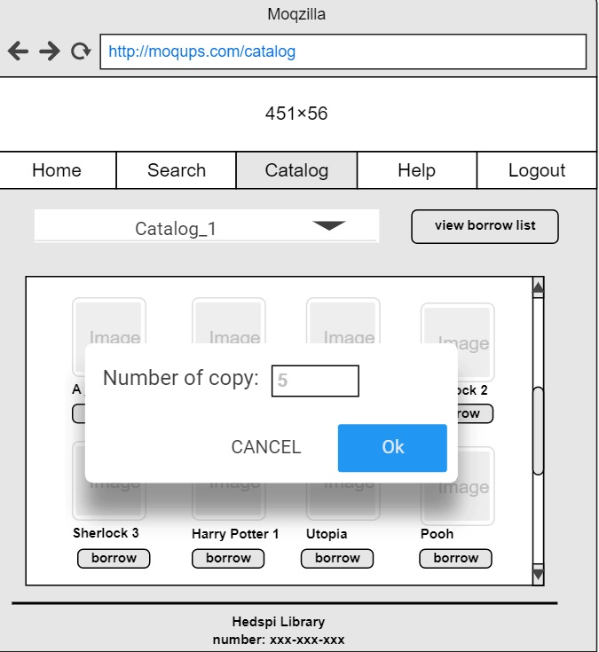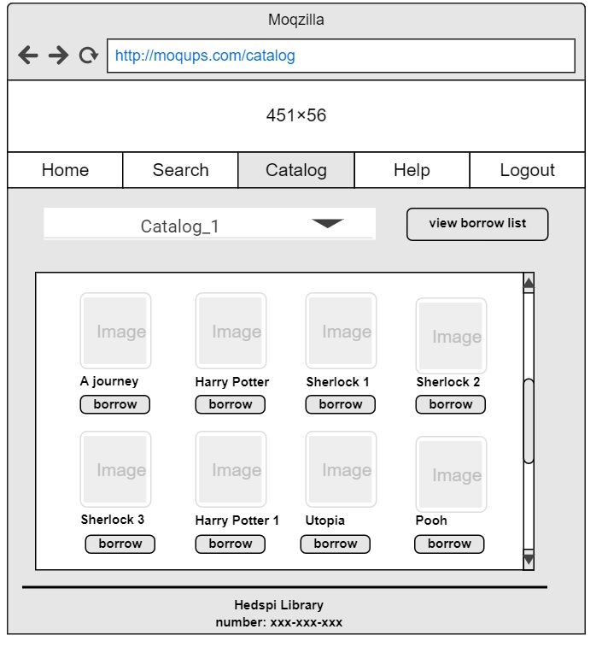

**Register to borrow screen**

